KASHIPUR MICHAEL MADHUSUDAN MAHAVIDYALAYA
(PERSONAL PROFILE)
Name: BHAJAN DANA 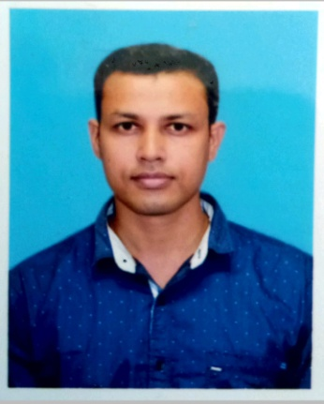
Designation: SACT-II
Date of Joining: 02/08/2010
e-mail: bhajudana@gmail.com

Educational Qualification:
- Post-graduation:
- M.Phil / Ph.D : Pursuing Ph.D

State Level / National / International Conferences /Seminars /Workshops /Webinar Attended:
- Paper Presentations in Seminars / Conferences / Webinars

- Participation in Seminars / Conferences / Training Programmes / Workshop / Webinars
- International Webinar on “COVID-19 CHALLENGES AND OPPERTUNITIES” on 5th June 2020.
- “Importance of Yoga in Daily Life” on 21st June 2020.
- International Webinar on “Let Them Anatomise Drama”: Text, Transformation, Performance, on 25th June 2020.
- Two day national webinar on “Impact of COVID-19 on Indian Society” on 29th& 30thjuly 2020.
- Webinar on “Recycling Waste Management in Theory and Practice” on 1st August 2020.
- National Webinar on “MOHAMARI: ITIHAS O UTTORAN” on 5th June 2020 .
- Two day national webinar on “on 29th& 30th July 2020.
- Two day national webinar on “Significance of Human Right during COVID-19 Pandemic Issues and Challenges” on August 2020.
- One day national webinar on “Environment & Sensibility: Land, Water & Ecosystem Perspective” on 31 August 2020.
- Online National Faculty Development Programmeon Research Methodology (for Humanities & Language) held on from 21st August to 27th August 2020, Organised by Rabindranath Tagore University, Bhopal.
- International Webinar on “LOK JIBONER SANGEET: BHATIYALI, BIHOO,BAUL” on 28th October 2020.
- One day webinar on “The Current Psychological Crisis in Education” on 5th January 2021.
- Two day national seminar on “The Saga of Unsung Tribal Heroes of Freedom Movement of India Projected in History, Literature and Print Media” on 28th& 29thMarch 2023.

List of Research Papers published in National / International Journals / Books / Conference Proceedings with ISBN / ISSN / Impact Factor:
- Books:
- N.A
B)Journals:
1. “Democratic Revolution inMeenaKandasamy’s novel The Gypsy Goddess”Published in Journal of Education, RabindraBharati University
C)Conference Proceedings:
1. N.A

Areas of Specialization in Research / Teaching:
- Specialization in Teaching:Indian writing in English

- In Research:Dalit Literature

Teaching:
- Theory: Theory
- Practical:
- Excursion / Field Survey:

Invited Lecture / Foreign Visit:
1.Other Academic Activities:Refresher Course on Gender Studies (IMD) held from 17th February 2022 – 3rd March 2022 held by CPDHE

- Board of Studies:N.A
- Course Design:N.A
- Paper Setter:N.A

Administrative Activities:

      - Member of Admission committee
      - Member of library committee
      - Member of examination committee

Associated with Learned Bodies / Association / Society / Organization:

1.

